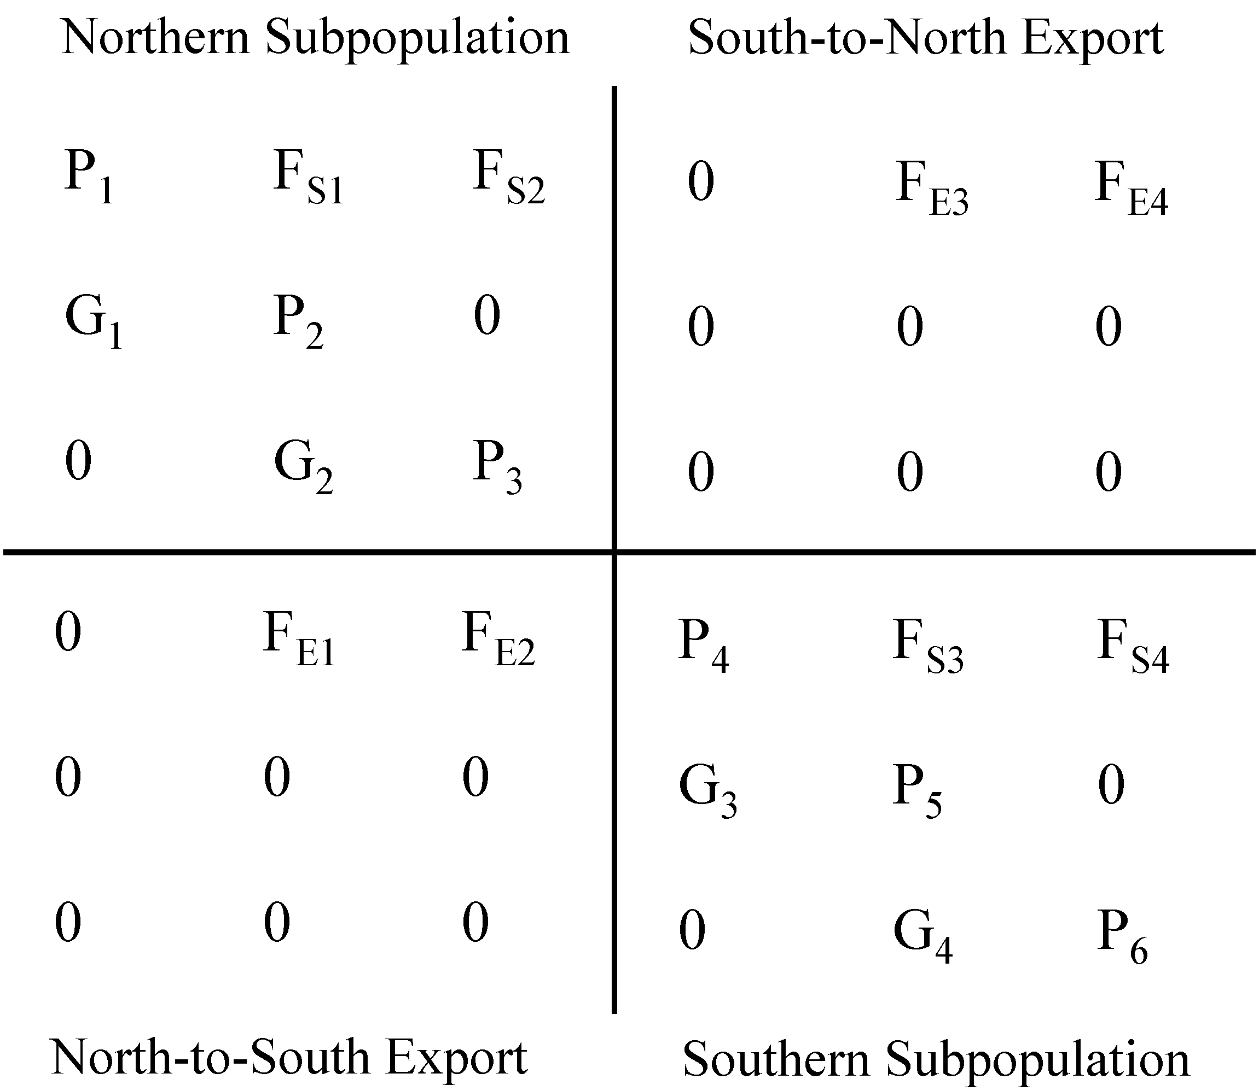
A. Overall model matrices:

Mytilus californianus

Spring (λ = 0.8402)
0.0074 | 12.15 | 24.49 | 0 | 5.15 | 10.37
0.0215 | 0.1660 | 0 | 0 | 0 | 0
0 | 0.1489 | 0.1861 | 0 | 0 | 0
0 | 13.99 | 28.20 | 0.0000 | 3.74 | 7.54
0 | 0 | 0 | 0.0263 | 0.1463 | 0
0 | 0 | 0 | 0 | 0.1281 | 0.1300

Fall (λ = 1.0022)
0.0030 | 8.23 | 16.58 | 0 | 26.23 | 52.85
0.0244 | 0.2443 | 0 | 0 | 0 | 0
0 | 0.0467 | 0.2565 | 0 | 0 | 0
0 | 10.65 | 21.46 | 0.0115 | 26.98 | 54.36
0 | 0 | 0 | 0.0144 | 0.1438 | 0
0 | 0 | 0 | 0 | 0.1257 | 0.4069
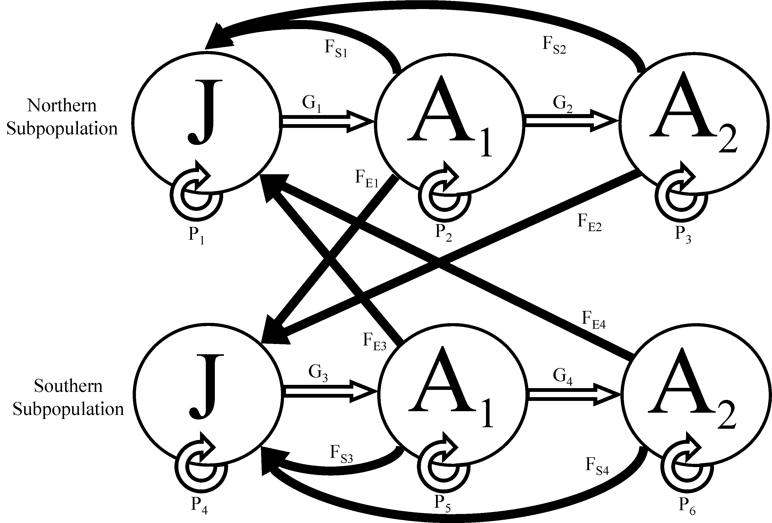
Annual: Spring x Fall (λ = 1.0792)
0.2965 | 4.1728 | 6.4044 | 0.0742 | 2.2382 | 4.6106
0.0041 | 0.2175 | 0.3565 | 0 | 0.5639 | 1.1363
0.0036 | 0.0451 | 0.0477 | 0 | 0 | 0
0.3414 | 4.7347 | 7.2333 | 0.0539 | 1.4856 | 3.068
0 | 0.2801 | 0.5644 | 0.0024 | 0.7306 | 1.4297
0 | 0 | 0 | 0.0018 | 0.0348 | 0.0529
Mytilus galloprovincialis

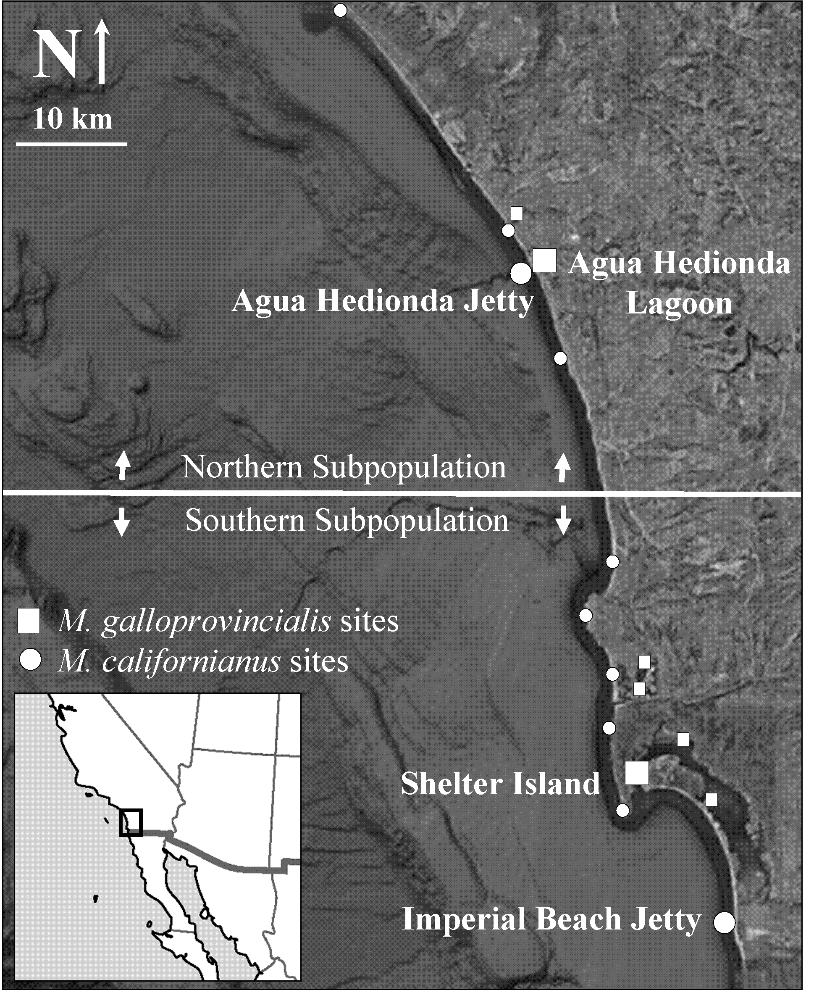
Spring (λ = 1.1748)
0.0047 | 29.10 | 58.63 | 0 | 4.44 | 8.95
0.0234 | 0.0315 | 0 | 0 | 0 | 0
0 | 0.2694 | 0.2860 | 0 | 0 | 0
0 | 31.23 | 62.93 | 0.0151 | 8.52 | 17.18
0 | 0 | 0 | 0.0227 | 0.1303 | 0
0 | 0 | 0 | 0 | 0.3150 | 0.3464

Fall (λ = 0.6444)
0.0047 | 2.78 | 5.60 | 0 | 2.50 | 5.03
0.0234 | 0.1870 | 0 | 0 | 0 | 0
0 | 0.1139 | 0.2860 | 0 | 0 | 0
0 | 3.57 | 7.18 | 0.0145 | 2.04 | 4.11
0 | 0 | 0 | 0.0218 | 0.2791 | 0
0 | 0 | 0 | 0 | 0.1464 | 0.4731

Annual: Spring x Fall (λ = 1.0243)
0.0651 | 1.733 | 1.8772 | 0.0568 | 1.9311 | 1.7845
0.0045 | 0.6868 | 1.3719 | 0 | 0.1039 | 0.2094
0.0027 | 0.0806 | 0.0818 | 0 | 0 | 0
0.0835 | 2.4996 | 2.966 | 0.0465 | 1.684 | 1.6728
0 | 0.6808 | 1.3719 | 0.0067 | 0.2221 | 0.3745
0 | 0 | 0 | 0.0033 | 0.1681 | 0.1639

B Elasticity matrices: Elasticity values for each matrix element in the overall model.
Mytilus californianus
Spring
0.1% | 2.5% | 0.7% | 0 | 0.7% | 0.8%
19.8% | 1.7% | 0 | 0 | 0 | 0
0 | 2.7% | 0.5% | 0 | 0 | 0
0 | 2.1% | 0.6% | 0.0% | 0.4% | 0.4%
0 | 0 | 0 | 59.0% | 2.2% | 0
0 | 0 | 0 | 0 | 3.8% | 2.1%

Fall
0.0% | 3.6% | 0.6% | 0 | 14.4% | 1.4%
4.7% | 4.3% | 0 | 0 | 0 | 0
0 | 1.2% | 0.5% | 0 | 0 | 0
0 | 12.5% | 2.1% | 0.2% | 40.3% | 4.0%
0 | 0 | 0 | 3.3% | 3.8% | 0
0 | 0 | 0 | 0 | 2.8% | 0.5%

Mytilus galloprovincialis
Spring
0.0% | 40.7% | 8.2% | 0 | 7.4% | 3.2%
3.2% | 0.8% | 0 | 0 | 0 | 0
0 | 9.8% | 1.0% | 0 | 0 | 0
0 | 9.8% | 2.0% | 0.0% | 3.2% | 1.4%
0 | 0 | 0 | 1.2% | 1.4% | 0
0 | 0 | 0 | 0 | 5.4% | 1.3%

Fall
0.1% | 0.3% | 1.0% | 0 | 0.4% | 1.4%
59.4% | 1.7% | 0 | 0 | 0 | 0
0 | 1.9% | 9.3% | 0 | 0 | 0
0 | 0.1% | 0.5% | 0.2% | 0.1% | 0.4%
0 | 0 | 0 | 16.3% | 1.1% | 0
0 | 0 | 0 | 0 | 0.9% | 4.9%

THESE DATA APPEAR AS ONLINE APPENDICES IN
Carson, H.S., G. Cook, M. Paola López-Duarte and Lisa A. Levin.
Evaluating the importance of demographic connectivity in a marine metapopulation
Ecology 92: 1972-84. This paper provides the demographic methods.

